**Prototype Data Persistence**

For the data persistence in the prototype we will store the data in the HANA Database and use XSODATA-Services to expose them.

Overview

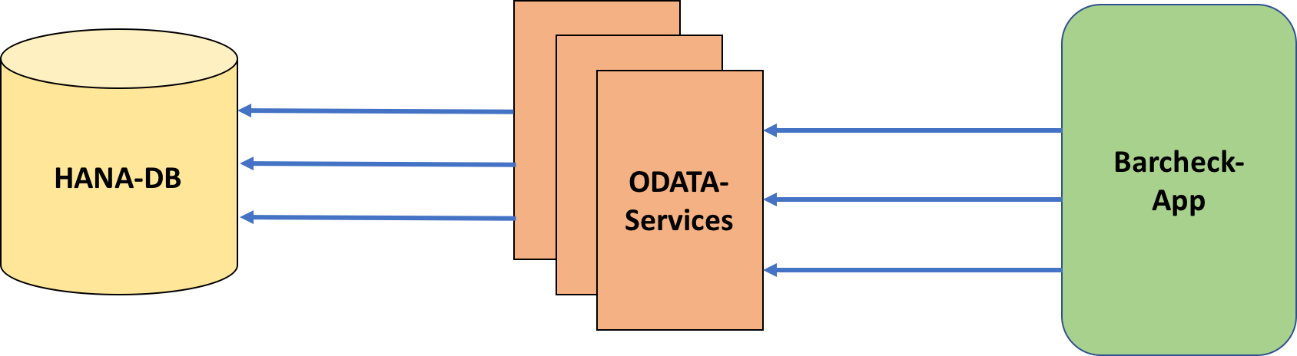

NOTE: If you want to insert new data please use the Insert Template for each relation in the HANA Workbench Editor (d064868 package) to generate an auto-increment id.

Services

**Contacts**

<https://bca3acb28be61.hana.ondemand.com/d064868/contact.xsodata>

**Relation**

<https://bca3acb28be61.hana.ondemand.com/d064868/relation.xsodata>

**Location**

<https://bca3acb28be61.hana.ondemand.com/d064868/location.xsodata>

Authentication

For reading the data, no authentication is needed. For write (CREATE, UPDATE, DELETE) use Basic Authentication with your HANA DB User.